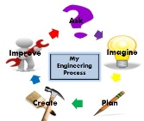
Woodland S.T.E.A.M. Integrated Plan
Living and Non-Living
Grade Level: Kindergarten | Time Frame: 10 weeks
Ask: How can we take care of nature and how does nature take care of us?

Focus Standards
Math:
MGSEK.MD.3 Classify objects into given categories; count the numbers of objects in each category and sort the categories by count.
MGSEK.OA.1 Represent addition and subtraction with objects, fingers, mental images, drawings, sounds (e.g., claps), acting out situations, verbal explanations, expressions, or equations.
Science:
SKL1. Students will sort living organisms and non-living materials into groups by observable physical attributes.
SKL2. Students will compare the similarities and differences in groups of organisms.
SKE2. Students will describe the physical attributes of rocks and soils.
SKCS5. Students will communicate scientific ideas and activities clearly.
ELA:
ELAGSEKRL1 With prompting and support, ask and answer questions about key details in a text.
ELAGSEKRI1 With prompting and support, ask and answer questions about key details in a text.
ELAGSEKRL2 With prompting and support, retell familiar stories, including key details.
ELAGSEKRI2 With prompting and support, identify the main topic (main idea) and retell key details of a text (supporting details).
ELAGSEKRL3 With prompting and support, identify characters, settings, and major events in a story.
ELAGSEKRI3 With prompting and support, describe the connection between two individuals, events, ideas, or pieces of information in a text.
ELAGSEKRL5 Recognize common types of texts (e.g., storybooks, poems).
ELAGSEKRI8 With prompting and support, identify the reasons an author gives to support points in a text.
ELAGSEKW7 With guidance and support, participate in shared research and writing projects (e.g., explore a number of books by a favorite author and express opinions about them).
ELAGSEKW8 With guidance and support from adults, recall information from experiences or gather information from provided sources to answer a question.
Essential Question(s)  - How can we describe the attributes of rocks and soils?  - How do we use rocks to help us?  - Why are worms important to the soil?  - How can we describe plants?  - How are plants different from other types of plants? (discuss different plants such as flowers, trees, bushes, grass, etc.)  - What types of soil help plants grow best?  - How do we use plants?  - How can we describe different groups of animals? (discuss mammals, reptiles, birds, ocean animals/fish)  - How do we use animals?  - How do rocks and soils help our earth?  - What are uses for rocks and soils?  - What are the physical attributes of rocks and soils? | Key Vocabulary Terms  - attribute  - classify/sort  - seed  - root  - petal  - leaf  - stem/stalk  - bud  - seedling/sprout  - evergreen  - habitat  - prey/predator  - carnivore/herbivore
Technology Needed  - Is it Living PPT (from Kindergarten, Kindergarten)  - rock ppt (in STEM folder)  - plant unit and nonfiction plant resource (in STEM folder) | Supplies Needed  - buckets for compost  - worms  - rock and soil samples  - microscope  - terranium supplies
Teaching the Target

March 15-18, 21-22-living and non-living
- http://www.kindergartenkindergarten.com/2012/03/a-science-mini-unit-living-and-non-living.html
- http://gpb.pbslearningmedia.org/resource/tdc02.sci.life.colt.lp_living/living-vs-nonliving/

Lesson 1: Tues
Introduction. In 2 separate hula hoops, TW only tell student yes or no in where to place their living/non-living picture cards. SW analyze pictures and discuss how the cards are sorted (living things vs. non-living things, etc.)
Independent: SW complete a living/non-living sort in their STEM journals.

Lesson 2: Wed
Powerpoint from KindergartenKindergarten website (see link above). During ppt,do not correct them right away. Allow students to discuss their answers. Stop at the slide with the stop sign! Lead students in a discussion with the following questions:
How can you tell if something is living or non-living?
What are some things that all living things have in common?
Resist the urge to correct any misconceptions. Write down all of their ideas on a big chart.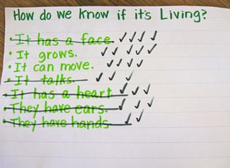
Choose an object that all of the kids can agree is absolutely, without a doubt, living--like a puppy! Go through each of the ideas on the chart. If it is true for the puppy, put a check. If it is not true, cross it out.
Now choose another living thing, but this time, choose an object you know will get a few more misconceptions crossed off that list. Butterfly got They have ears crossed off. A sunflower got It has a face and It has a heart crossed off. Keep going until you have all of the misconceptions crossed off and you will have the beginnings of a list of what all living things have in common.
Note: Your kids will most likely want to cross off It can move or It can breathe (or a few others) for a plant or a tree. After all, they do not obviously move or breathe. So you will probably have to have a quick discussion about how plants move and breathe at this point.
Your class will probably not think of all the things living things have in common. You can see we only had It grows and It can move. Finish the rest of the Is it Living PowerPoint. Now you can add the other criteria to your list.
Independent for Integrated Reading Station: Living vs. Non-Living Sort in STEM journals.

Lesson 3: Thurs
Book:
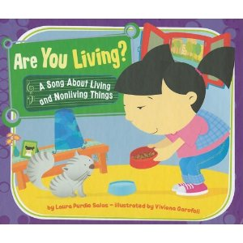
Lesson: As you read books, make an anchor chart listing all of the things living things have in common. Complete half the anchor chart.
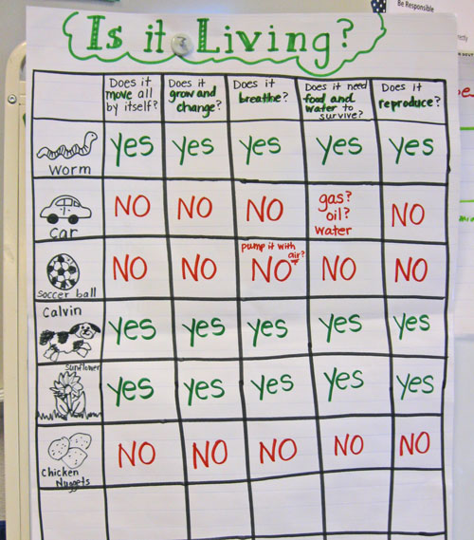
Independent Work: Living vs. Non-Living sort in STEM journals (kindergartenkindergarten site)
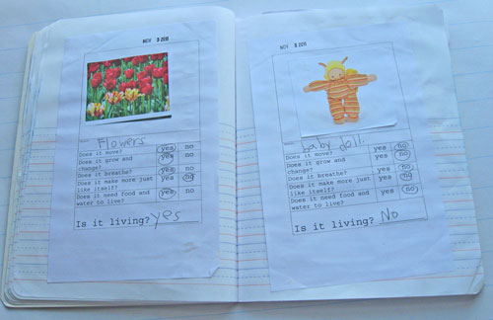

Lesson 4: Fri
Lesson: Complete the anchor chart from the previous day.
Independent: SW choose something that is living or nonliving and determine if it’s living or non-living in their STEM journals.
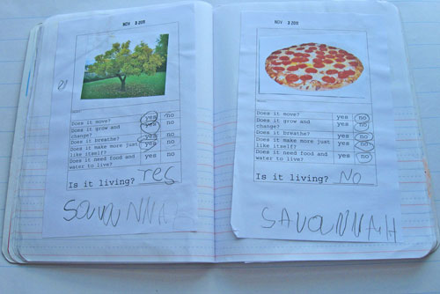
Lesson 5: Monday
-Living and non-living field trip
-TSW write in their STEAM journal a reflection piece from the field trip. What did you learn about living and non-living?

Lesson 6: Tuesday
- http://www.stemmom.org/2013/04/terrarium-building-with-students.html
-STEAM challenge: How can we create a terrarium that includes living organism and non-materials?
(terrarium layer order: small rocks, charcoal, sand, dirt)
-questions to ask:
1. What are you working on? Why are you making a terrarium?
2. What is the engineering design model? How do you use it and why do you need it?
3. How do you know _________ is living (or nonliving)?
4. How do the nonliving materials help the living organisms? What would happen to the living organisms without the nonliving materials?
5. Are you more like a (nonliving material) or (living organism)? Why?

-ASMT
math: picture addition class assignment
science/reading: living/non-living sort
ELA: living and non-living opinion paper (Can they state an opinion)

March 23-25, 28-April 1-rocks and soil
-describe attributes of rocks using 5 senses (large/small, heavy/light, dark/light, rough smooth, etc.)
-how do we use rocks
-compare different soils (planting soil, sand, red clay) (Liz asking Mason for rock and soil samples, microscope?)
-real-word connection: erosion
-worms and soil; build compost pile

Day 1:
https://jr.brainpop.com/science/land/rocksandminerals/
Introduce Rocks/Minerals and with BrainPopJr video. Discuss prior knowledge of topic with students. Create KWL or Schema Chart of “what we already know about rocks”. Go on nature walk around school with STEM journal. Observe different types of rocks around the school, SW record findings and rock characteristics in STEM journals.

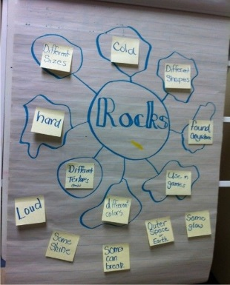

Day 2:
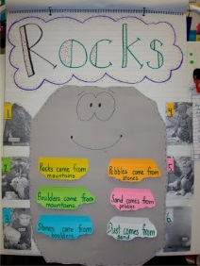
Activity- “Rock Detector” compare two types of rocks; complete compare/ contrast chart (color, texture, size, shape, grains) TSW take their stem journal outside and find two rocks and compare the color, texture, size, shape and grain. TTW read Let’s Go Rock Collecting. Let students look at some rocks. Begin or Finish -Write the rock property headings on chart paper: Color, texture, shape, size, grains. Have students describe their rocks. See examples in Monday’s column. Students can bring at least one rock to school tomorrow to describe.

Day 3:
TSW use their three rocks from the day before and the teacher will discuss the rock anchor chart- discuss that all rocks are shaped and sized differently. Today we will go on a rock hunt and collect three rocks. Each student will then collect three rocks. TTW model how to compare rocks and measure them using unifix cubes. TSW then ordered the rocks by size in their steam journal and discuss which is the shortest and which is the longest. TSW use addition to determine how long the rocks are all together.

Day 4: Watch power point called, What do we use rocks for? Make a list of their uses.
Finish if necessary going over Rock properties. Why are rocks important to the earth? Look at rocks students brought to school. Can we add some more descriptive words to the rock properties (physical attributes)?
TSW use their rock collection from yesterday and TSW complete Rock Measurement mini-unit: collect rock from outdoor classroom or playground, make predictions about weight in steam journal and TSW use the balance to weigh the different rocks. TSW will order the rocks from the least amount of weight to the most amount of weight; use balance and scale to weigh it.

Day 5:
https://jr.brainpop.com/science/land/soil/
Introduce Soils and with BrainPopJr video. Discuss prior knowledge of topic with students. Create KWL or Schema Chart of “what we already know about soil”. Go on nature walk around school with STEM journal. Observe different types of soil/dirt around the school, SW record findings and rock characteristics in STEM journals. Make sure to walk around different areas of school to show students different types of soil: STEM Gardens, lower playground, upper playground, etc… Watch brain pop Jr. called Soil. Discuss video. Take online quiz. Discuss what soil is made of. Create a chart using the acronym WHAM.
W-weathered rock
H-humus
A-air and water
M-minerals
Let students observe some soils. Use senses to feel, smell, and touch. Can you hear it? Can we taste it?

Day 6: TTW will read A Day for Digging; Two Soils: Compare/contrast activity; observe, compare, write about two different soils in steam journal. TSW then go to the gardens do observe the different plants and what type of soil they use.

Day 7: TTW read The Diary of A Worm and TTW will discuss how we take care of our world? Then TTW go over worm powerpoint and what a worm is useful for. In their journal, TSW draw and label a worm and the type of soil they need to live in and why. Review fiction and non-fiction genres of soil and rock books on youtube and TSW put a thumbs up if it is non-fiction and thumbs down if it is fiction (informative assessment) TTW ask the purpose of the authors story.

Day 8:
STEM EDP Challenge Activity on TeacherShare called: “Rocks and Soils at School”

Other Ideas:
-play "find my rock" by giving clues
-pet rock (describe; watch Sesame St "Rock show and tell")
-rocks are everywhere PPT
-how do we use rocks? (class book)
-book: Why do we need rocks and minerals? (EPIC...it's ok)
book: How the meteorite got to the museum (EPIC...rocks in space)

books:
-Fossils Tell of Long Ago by Aliki (Young)
-Let’s Go Rock Collecting by Roma Gans (Young)
-Slimy Slugs and Grybby Bugs (Young)

April 11-15, 18-22-plants; Earth day
-compare different types of plants (flowers, trees, bushes, grass, etc.)
-discuss different uses of plants
-real-world connection: protect bees so they can pollinate plants
-read The Lorax
-discuss ways to take care of the Earth
-recycle paper

Day 1:
-read Jack and the Beanstalk
-use the 5 finger comprehension strategy to review story elements. Let students retell the story with a partner:
finger 1-Who are the characters?
finger 2-Where is the setting?
finger 3-What is the problem?
finger 4-What are the events that happened?
finger 5-How did the story end (solution)?
-ask: Do you think Jack’s beanstalk was real? If it were real, would it be living or non-living?
-explain that beans are a type of plant. What are other types of plants? What do you know about plants? Begin a plant schema chart.
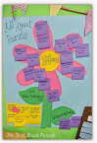

Day 2:
-review plant schema chart
-Let’s research about plants! What does research mean? We are going to find more information. Where are places to research? (nonfiction books, websites, videos, etc).
-begin reading Seeds to Plant or a similar nonfiction plant book. What details are you learning about plants? Record new learning on the schema chart.
-ask: How is Jack’s beanstalk like the plants we just researched? Did it start as a seed? What’s the seed of a beanstalk? Show students a bean like the one Jack received. What do they notice?
-show letter from Jack (in plant PPT)
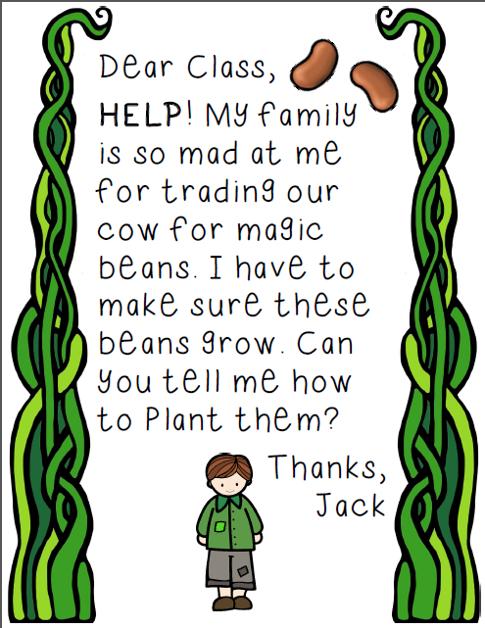
2 planting experiments (do either, both, or neither):
1. Beans and the Cloud Castle (http://ckisloski.blogspot.com/2016/02/jack-and-beanstalk-and-lots-of-freebies.html )
-TSW plant a seed in a clear plastic cup. To add a little artsy flare, add your own castle in the clouds to each plant. Glue cotton on the bottom of a picture of a castle. Attach the picture to a dowel stick or straw and put in the cup with the seed. Will our beanstalk grow to the clouds like Jack’s did? (materials: cup, soil, shovel, straw/dowels, cotton, castle pictures).
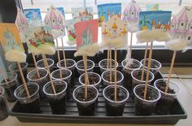
-at writing station: write a how-to book on how to plant a seed. Possible steps:
1. dig a hole
2. put seeds in the hole
3. cover the hole with dirt
4. water the hole

2. Sprout House (https://www.teacherspayteachers.com/Product/My-Little-Sprout-House-Printable-1218023)
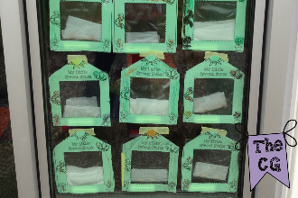

Day 3:
-We have been talking about plants. But plants can look very different.
-look at p. 4 in plant unit PDF (in STEM folder); ask questions such as:
1. What do you notice about these plants’ size and color?
2. Would you eat any of these plants?
3. What do you see in these pictures that is the same? Different?
4. What do you wonder about these pictures?
-look at p. 5-8 and compare and contrast each pair of plants. Help students to see that even though these plants look different, they are all plants and they are all living.
-go on a nature walk and look at different types of plants. TSW use their STEAM journal to record one or both of the following activities:
1. nature scavenger hunt (plant unit PDF, p. 11)
2. alike or different? (plant unit PDF, p. 12)

Day 4:
-read the 2nd letter from Jack asking about what plants need.
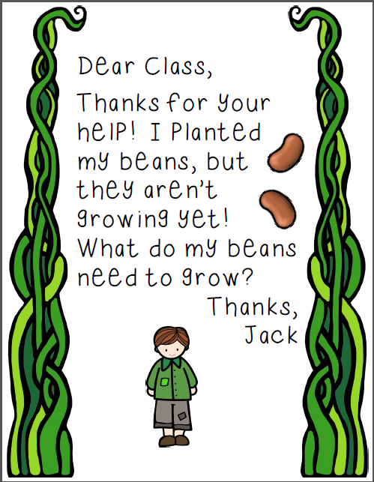
-research plant needs (plant nonfiction book, plant nonfiction resource PDF p. 78, etc.)
-possible questions to ask:
1. Do all plants need the same thing?
2. Which soil…sand, red clay, or potting soil…would help plants grow the best? Why?
3. Could a plant grow in the closet? Why or why not?
4. What might happen to plants if it doesn’t rain for a long time?
5. How can we help plants get the things they need?
-add new learning to the schema chart
-complete plant need flap book or art project to “send to Jack” so he will know how to care for his beans
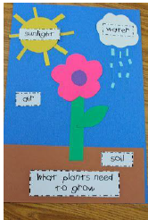 or 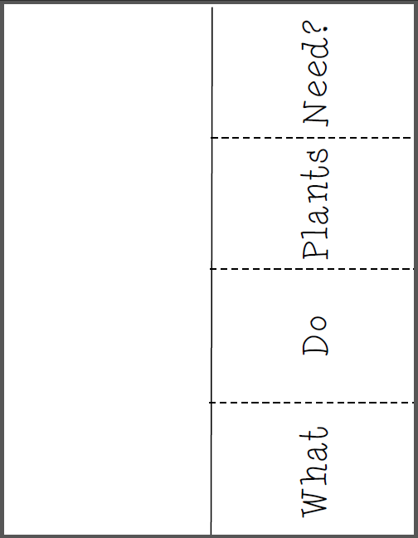
-begin plants need experiment: buy 3 identical potted plants. Give one water and sunlight, give one no water, and give one no sun. What do you think will happen? Which plant will grow best?

Day 5:
-Explain that our bodies have parts that help us to live. Plants also have parts.
-research the parts of a plant (plant nonfiction book, plant nonfiction resource PDF p. 77, etc.)
-song: (tune: head, shoulders, knees, and toes)
“Flowers, stem, leaves and roots, leaves and roots.
Flowers, stem, leaves and roots, leaves and roots.
All it takes is sun and showers.
Then a seed turns into a flower.”
-Ask: How do each of these parts help the plants grow and live?”
-Ask: Do different types of plants have the same parts? Review the pictures on p. 4-8 in plant unit PDF (in STEM folder). Where are the flowers, stems, leaves, and roots on these plants?
-add new learning to the schema chart

STEAM PROJECT (in STEM folder): Create a plant with all parts (roots, stems, leaves, flowers). Label each part.

day 6:
-Introduce Earth Day.
-ask: Why do you think this day is important? Why is it important to take care of the Earth?
-Read The Lorax
-use the 5 finger comprehension strategy to review story elements. Let students retell the story with a partner:
finger 1-Who are the characters?
finger 2-Where is the setting?
finger 3-What is the problem?
finger 4-What are the events that happened?
finger 5-How did the story end (solution)?
-Begin schema chart of ways to take care of the Earth (could be shaped like a truffula tree)

day 7:
-Brainpop: Reduce, Reuse, Recycle
-ask and answer Q. about video; add new learning to truffula tree map
-Introduce new vocabulary: reduce, reuse, recycle
-complete sort. What can be reduced, reused, or recycled?
-Lorax writing activity: how we can help our earth (could be completed at the writing station)

day 8:
-Introduce Earth Day Poem
-review roles of author/illustrators
-illustrate poem making sure that each picture matches the text

day 9:
-give students a paper plate; TSW write/draw as many fruits/veggies as they can think of; discuss which are fruits and which are vegetables
-read information about fruits and vegetables and answer Q: How are fruits and vegetables the same and different?
-Revisit paper plate and decide which are fruits and which are vegetables

day 10:
-discuss what part of the plant a vegetable comes from; complete sort
-read Tops and Bottoms
-complete Tops and Bottoms retelling activity

books:
non-fiction
From Seed to Plant Gail Gibbons
How a Seed Grows by Helene Jordan
Seed to Plant by Kristin Baird Rattini (National Geographic Kids)
Be a Friend to Trees by Patricia Lauber
Recycle by Gail Gibbons
Our Class is Going Green by kindergartners @ Oak Park Elem.
Oh Say Can you Seed by Bonnie Worth (The Cat in the Hat Knows a lot about That)

fiction
Tops and Bottom
Jack and the Beanstalk
Tiny Seed by Eric Carle
Lorax by Dr. Seuss
The Giving Tree by Shel Silverstein
Growig Vegetable Soup by Lois Ehlert

Youtube video:
Ms Booksy Jack and the Beanstalk
SuperWhy Jack and the Beanstalk

April 25-29-mammals/babies
-movement
-body covering
-body parts
-habitat
-diet (carnivore/herbivore), (predator/prey)

May 2-6-mammals/babies
*field trip-5/4

May 9-13-reptiles/amphibians/babies
(repeat questions from mammals)

May 16-20-birds/babies
(repeat questions from mammals)

May 23-27-ocean animals/fish/babies
(repeat questions from mammals)
Assessment:
math: picture addition class assignment
science/reading: living/non-living sort
ELA: living and non-living opinion paper (Can they state an opinion)

Career Connection:
-Gina Gill-tour of the garden

Resources:
-living/non-living sort (color and b/w journals)
-discovery ed videos
-Sesame St living/non-living video: https://www.youtube.com/watch?v=giWqEPNLtBo
-song (tune: “Where is Thumbkin?”)
“Is it living? Is it living?
I know why. I know why.
It eats and breathes and grows. It eats and breathes and grows.
It’s alive. It’s alive.”
-

