Woodland Data Talk protocol

Norms

1. Come with data ready to be analyzed
2. Keep the focus on student learning
3. Cast no blame. Data is used for sole purpose of determining how to be more effective.
4. Approach analysis as a learner. There are no right or wrong answers.

Facilitator—Keep the protocol on track with time and adherence to the rules of each phase.

C:\Users\williamsk6\AppData\Local\Microsoft\Windows\Temporary Internet Files\Content.IE5\5CU3027H\MC900088978[1].wmf***Private Think Time—*** Instruct the participants to take a few moments to review the data. This should be a quiet time without comments.

***Observations*** *–In this phase, participants engage with the data and note only facts that are observable in the data. Conjectures, explanations, conclusions, and inferences are off limits. Remember just the facts in this round. If participants use any of the following phrases, “however”, “because”, “therefore”… remind them of the rules of the phase.*

* Round 1—What important observations seem to “pop out” from the data? Did anything surprise you?
* Round 2—What patterns or trends appear in the data?

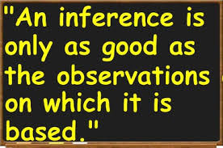***Inferences****—During this phase, participants generate multiple explanations for their Phase I observations, identify any additional data that may be needed to confirm/contradict their explanations, identify data needed to monitor implementation of their solutions*

* Round 3—Use one or more of the following statements to prompt participants…
* “I believe the data suggests… because…”
* “Additional data that would help me verify my explanation is…”
* “I think the following are appropriate soltuions to address the needs implied by the data…”
* “Additional data that would help to guide implementation of solutions/responses to determine if they are working are…”